A.KPI’S
1.Total Revenue:
Select Sum(total_price) As Total_Revenue From pizza_sales;
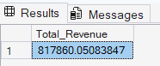
2.Average Order Value:
Select sum(total_price) / count(distinct order_id) as Avg_order_value from Pizza_sales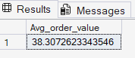
3.Total Pizza Sold:
select sum(quantity) as Total_pizza_sold from pizza_sales
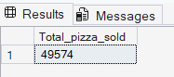
4.Total Orders:
select count(distinct order_id) as Total_orders from pizza_sales
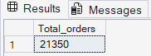
5.Average Pizzas per Order:
select cast(sum(quantity) as decimal(10,2)) / cast(count(distinct order_id) as decimal(10,2)) As avg_pizzas_per_order from pizza_sales
select cast(cast(sum(quantity) as decimal(10,2)) / cast(count(distinct order_id) as decimal(10,2)) as decimal(10,2))As avg_pizza_per_order from pizza_sales
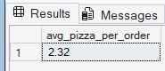
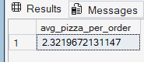
B.Problem Satement:
6.Daily Trends for Total Orders:
Select DATENAME(DW,order_date) as Order_day ,COUNT(distinct order_id) as Total_orders
From pizza_sales
Group by DATENAME(DW,Order_date) ORDER BY Total_orders ASC;
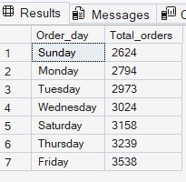
7.Hourly Trend for Total Orders:
Select DATEPART(HOUR,Order_time) as Order_hours,Count(distinct order_id) as Total_orders
From pizza_sales
Group by DATEPART(HOUR,Order_time) order by Total_orders ,DATEPART(HOUR,Order_time)
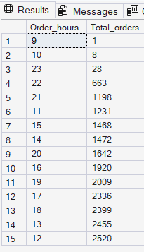
8.Percentage of Sales by category:
Select Pizza_category,sum(total_price) as Total_sales,sum(total_price)*100 / (select sum(total_price) from pizza_sales) as percentage_total_sales
from pizza_sales
group by pizza_category
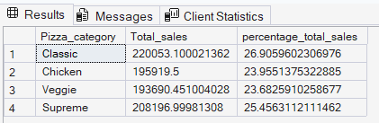
Select Pizza_category,sum(total_price) as Total_sales,sum(total_price)*100 / (select sum(total_price) from pizza_sales WHERE MONTH(Order_date)=1) as percentage_total_sales
from pizza_sales where month(order_date) =1
group by pizza_category
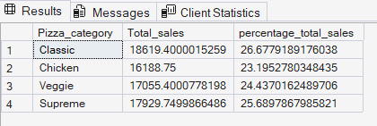
If you want to apply the Month,Quarter,Week filters to the above queries you can use WHERE CLAUSE .
9. % of total pizza size:
select Pizza_size,SUM(total_price) as Total_sales,sum(total_price)*100 /(select sum(total_price) from pizza_sales) as Percentage_total_sales
from Pizza_sales
Group by Pizza_size
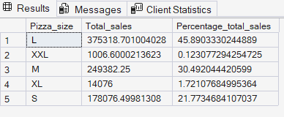
10.Total pizza sold by Category:
Select pizza_category,sum(quantity) as Total_pizza_sold
From pizza_sales
Group by pizza_category
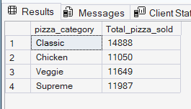
11. Top 5 Best Sellers by Total pizza sold:
select Top 5 pizza_name,sum(quantity) as Total_Pizzas_sold
from pizza_sales
Group by Pizza_name
Order by Total_pizzas_sold desc
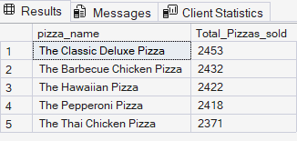
12.Bottom 5 worst sellers by Total pizza sold:
select TOP 5 pizza_name,sum(quantity) as Total_Pizzas_sold
from pizza_sales
Group by Pizza_name
Order by Total_pizzas_sold asc
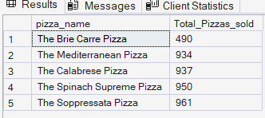
If you want to see according to month January I case august change the number 8
select TOP 5 pizza_name,sum(quantity) as Total_Pizzas_sold
from pizza_sales where month(order_date)=1
Group by Pizza_name
Order by Total_pizzas_sold asc
